Lou-Ann COCAULT
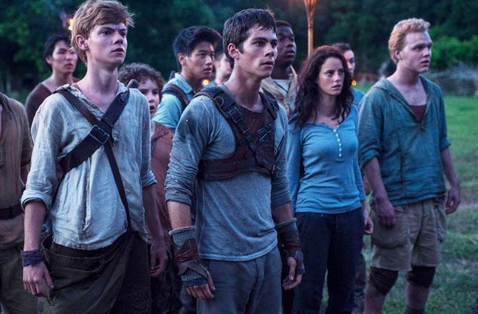
To begin, I chose « The Maze Runner » as a dystopian movie. It’s a dystopian and fictional universe in which any chance of happiness seems utopic. In this film, we discover Thomas (the main character) who regains consciousness and who is locked in a maze with other boys. This labyrinth is huge and its plan changes every night. They will have to find a way to escape.
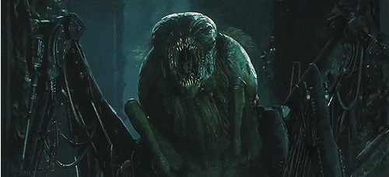
Moreover in this movie we discover a lot of dystopian elements like the monsters who are locked up in the maze : « Grievers ».

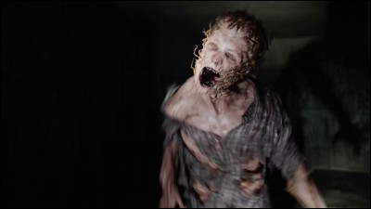
We learned that outside world is almost lifeless due to a virus : « The Flare » which was unfortunately created by man and released during the chaos caused by solar flares.
Consequently humans are placed in quarantine but this is not enough to eradicate the disease. The humans are transformed into creatures named : « Cranks ». Many people are contaminated mostly through bite.
We also learned that an organization called : « wicked » or « w.c.k.d » is doing a lot of research in order to find a cure for this virus…

In conclusion it’s a post apocalyptic world in which there are many advances futuristic scientists. The characters may encounter problems but hope is put forward.

