One Piece is a Japanese manga created by Eiichiro Oda in 1997 that has become
insone of the most popular and influential manga of all time. The story follows Monkey D. Luffy and his crew, the Straw Hats, in their quest to find the legendary treasure, the One Piece. During their adventure, they explore a vast world of fascinating and varied islands. Each island presents unique environments, distinct cultures and unique challenges, contributing to the richness and diversity of the manga universe.

IS ONE PIECE DYSTOPIC ?

Within the tales of adventures and emblematic characters of the manga "One Piece", emerges a fantastic universe where geographical problems are distorted to reveal dystopian aspects.. The stakes of global warming and the destruction of the environment take an unexpected form. By exploring the islands of "One Piece", we will discover how this manga is a dystopian work of geographical problems?. We will begin by examining the deformation of global warming across the Punk Hazard and Drum islands, and then we will analyze how environmental destruction manifests itself on the Fishman and Wano Kuni islands
ISLAND OF PUNK HAZARD

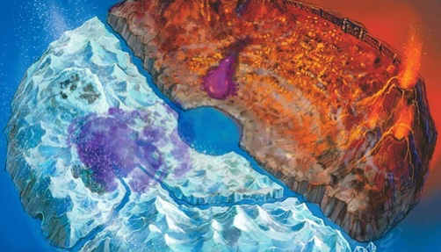
In the captivating universe of "One Piece", the islands of Punk Hazard and Drum stand as striking witnesses of the geographical disturbances induced by global warming.Indeed, it is the disturbing coexistence between burning flames and frozen expanses on this island of the New World that embodies the first aspect of this geographical dystopia. This duality reflects both climate chaos and the fragility of geographical balances. Moreover, the geographical upheavals caused by climate change reveal another worrying dimension. Once a harmonious place, the island is now marked by the transformation of its landscape into an arid and dangerous area. The consequences are dramatic: fish resources have been strongly affected, causing the disappearance of certain species of fish, such as coral fish that are sensitive to temperature variations. This disruption in the food chain also impacts other marine species, causing an ecological imbalance. Moreover, the mutation of marine species has upset the delicate balance of the marine ecosystem. For example, crustaceans that were once small grew into creatures of disproportionate size due to altered environmental conditions. This transformation disrupts the delicate balance of the marine ecosystem, the consequences are devastating for marine fauna and fisheries resources, highlighting the dystopian aspect of these geographical changes

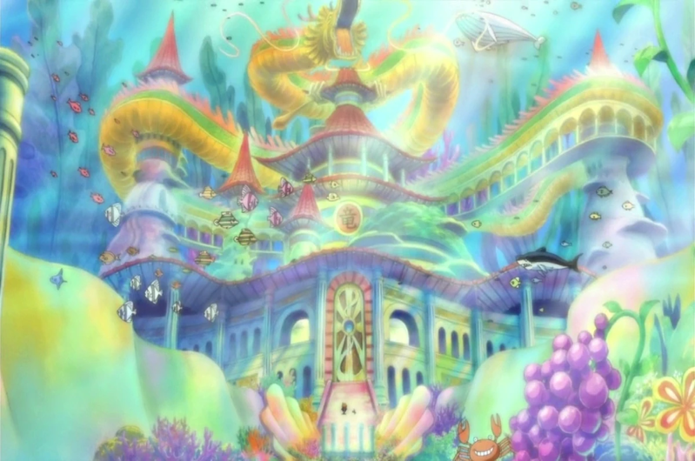
ISLAND OF FISH-MAN
In conclusion, the manga "One Piece" turns out to be a dystopian work by staging islands such as Wano Kuni, Fish-Man, Punk Hazard and Drum. Each of these islands vividly illustrates the devastating effects of climate change and environmental destruction. The discordant coexistence of formerly harmonious elements reflects the geographical dystopia of this universe. These islands offer a startling insight into how environmental imbalances lead to catastrophic consequences for ecosystems and populations. Thus, "One Piece" reminds us of the fragility of our world in the face of climate and environmental challenges, while stressing the crucial importance of protecting our planet to avoid a very real dystopia
CONCLUSION
Although its island is firm for the terrestrial population this does not prevent its marine ecosystem from being confronted with serious impacts of global warming , and coral reefs and ocean currents are threatened. This deterioration has had a huge impact on marine biodiversity and the lives of its inhabitants. Some are forced to migrate to escape adverse impacts, exacerbated by increased vulnerability to natural disasters. The gradual deterioration of the environment made the inhabitants desperate for a long time to finish again.

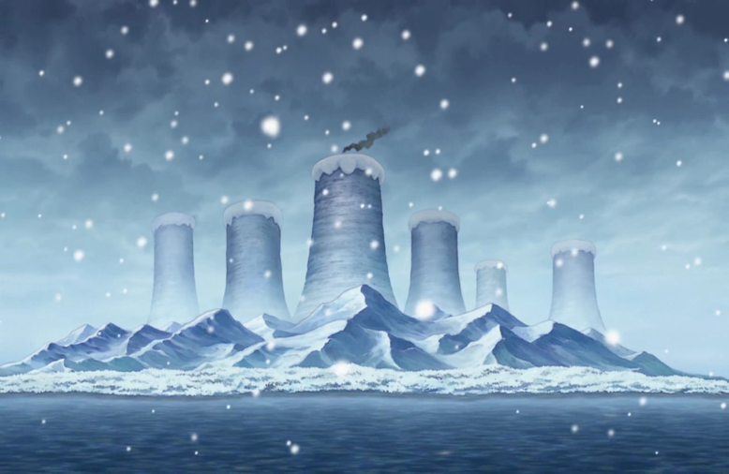
ISLAND OF DRUM

Drum Island, once a green haven, has been transformed into an icy landscape by rising sea levels and coastal flooding. The threatening shadow of sea level rise creates an atmosphere of uncertainty, leading to more frequent coastal flooding. These geographic changes have serious consequences on land and resources, undermining coastal ecosystems. Coastal fishing areas, once thriving, are experiencing recurrent flooding, disrupting marine wildlife and hindering fishing activities..

Another major challenge is the increase in storms and extreme weather events. Island populations are exposed to severe storms and excessive snowfall, causing considerable damage to local infrastructure and resources. Instability due to unpredictable climatic phenomena weakens geographical balances. Frequent tropical storms can erode coastlines, threaten coastal habitats and alter the breeding grounds of marine species.As global warming forges disturbed landscapes on these islands, it is crucial to also examine how this environmental alteration has led to progressive destruction

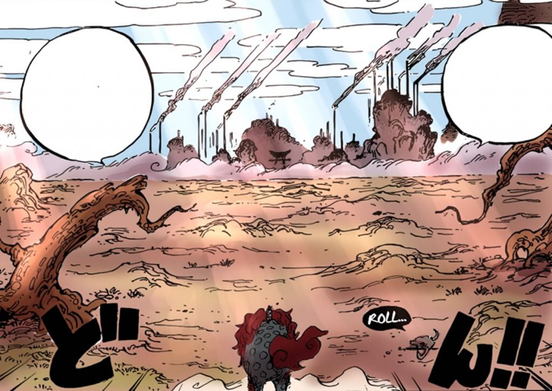
ISLAND OF WANO KUNI moi
Although closed to most of the world’s population, Wanokuni and Fishman Island are striking examples of the devastating consequences of environmental damage.Wanokuni faces a major challenge: the shortage of fresh water. Due to geographic isolation, access to drinking water is becoming complex, compounded by the scarcity of this resource. This situation has a serious impact on agricultural activities and the daily lives of the inhabitants. For example, harvests are declining, threatening food security. At the same time, deforestation is worsening this situation by destroying habitats and biodiversity. Unique plant and animal species are disappearing, as are the rare birds of the island. Soil degradation increases the risk of erosion, thus increasing territorial vulnerability. These environmental concerns underscore the need for action to preserve Wanokuni. Human interaction with the environment is central to these transformations. A comprehensive understanding is therefore crucial to ensure a sustainable future for this iconic island.

