Lyla Mars

This is when the novel takes place.

The government is totalitarian. It controls the population through Algorithma, a software which decides who is your soulmate that you have to marry. It choses your soulmate with your DNA and psychological compatibility.

The state submits the population to this algorithm by promising them a better couple, therefore a perfect life, and hence a better society.

The people have to respect a lot of rules, like filling out psychological forms regulary, which enables the government to watch over them.

In addition, couples must be heterosexual and people are prohibited to love somebody with whom they don’t have a high enough percentage of compatibility.

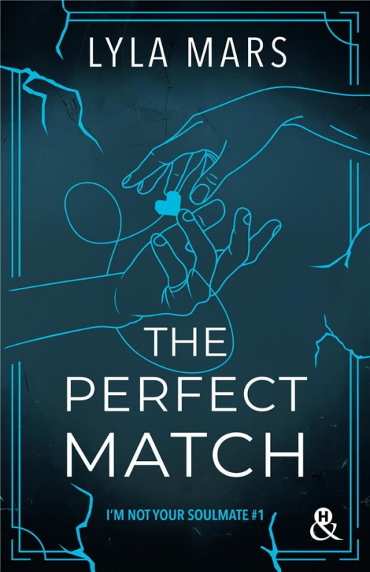

♡ 2050 ♡

♡ 2550 ♡

Their world has became dystopian because of an increase in depression, caused by loneliness increasingly affecting people in the the 21st century. Humanity was then unhappy and humans closed in on themselves.

All this discomfort was the cause of the 1st chimical war. It destroyed a large part of earth and caused the multiplication of global epidemics.

In the United States, due to the global decline of the population, the 50 states disappeared to make way to 10 « State Districts ».

Scientists are controlling the districts by supporting their legitimacy with the power they held on the vaccines they have created, thus making it possible to overcome the numerous epidemics. Their government relies on science and on the principles of a soulmate, which could help save their civilization at thier opinion.

HOW THEIR WORLD BECAME DYSTOPIC ?

volumes 1 & 2

**I’M NOT YOUR SOULMATE**

♡

♡

♡

♡It is a dystopic universe because it is a nightmare-futur. ♡ It’s something pretty basic… But the autor exagerrates the consequences going so far as to justify the war and pandemics by it. The unhappiness was the beggining to the fall of the 21st century society and the fundation of the dictatorship. The 21st century depression is the reason of all the misfortunes of characters in an indirect way.

Lyla Mars tells us the dangers of unhappyness and how it’s could destroy a family, influence bad descisions and how our mood could rub off on others.

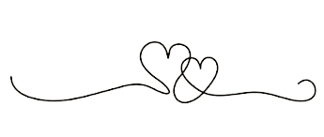

The reason of my choice

Lucile TOURET

♡♡♡♡♡♡♡♡♡

♡

♡♡♡♡♡♡♡♡♡

♡

I chose this duology because when I had to decide which work to study in the dystopic style, the first volume was very popular. So I have looked at the subject of the book and I was hooked by the summary. There are romance, dramas and rebellion : EVERYTHING I LIKE!

So I read the two novels, and I loved them. The plot is a page turner and I love the characters who are appealing and have a good evolution.

I like the fact that the cause of the destruction of the society was something really basic which degenerated. Moreover it could be possible in our world .

With this dystopia, the autor shows us how we could be controlled by algorithms. How the people could feel reassure when they don’t have to decide anything, even if it’s their life.

Maybe it’s already happening. It’s the aim of dating websites : an algorithm proposes us some people with whom we « match ». The book amplifies this and show us that it distorts love and standardizes it.

They are very interresting books, which I advise to anyone who loves science fiction, romance and dystopia.